 | 10 Editors - Compositor
Table of content
Compositor Editor 3
Navigating in the Compositing Editor viewport 3
Hotkeys 3
Preview Image in nodes 4
Collapsing Nodes 4
Rename Socket names 5
Node drag search 5
Node context menu 5
Add 6
Find 6
Cut Links 6
Mute Links 6
Exit Group 6
Copy 6
Paste 6
Duplicate 6
Rename 7
Delete 7
Delete with Reconnect 7
Make Links 7
Make and Replace Links 7
Detach Links 7
Make Group 7
Insert into Group 8
Toggle Edit Group 9
Ungroup 9
Join new Frame 9
Remove from Frame 9
Rename 9
Select submenu 9
Grouped 9
Linked From 9
Linked To 9
Activate same type previous 9
Activate same type next 9
Show/Hide submenu 10
Hide 10
Toggle Node Mute 10
Toggle Node Preview 10
Toggle hidden node sockets 10
Toggle Node Options 10
Collapse and Hide Unused Sockets 10
Toggle Node Options 11
Collapse and Hide Unused Sockets 11
Quick Favorites menu 11
Slider snapping 11
Hotkey only functionality 12
Back image Sample - Alt Right Mouse 12

Compositor Editor
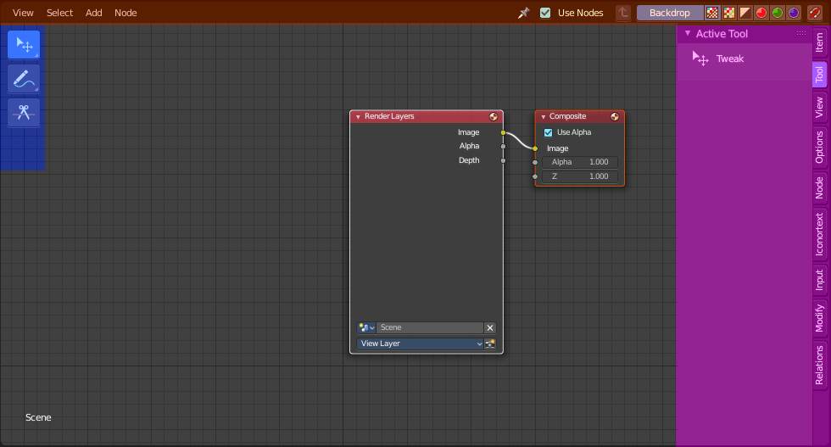
The Compositing editor allows you to do compositing. This means to modify and combine image layers in many different ways and by lots of available nodes. You can glue two pieces of footage together, colorize a whole image sequence at once and do all the traditional compositing steps that you usually would do in a 2d software.
The editor is divided into several areas.
Yellow – Header
Blue - Tool Shelf
Pink - Sidebar
Note that the editor does not have a tool area above the header. All tool settings are in the sidebar in the Tool tab.

Navigating in the Compositing Editor viewport

Hotkeys
Pan the view - MMB
Zoom - Mouse Wheel, MMB+CTRL, Numpad + / -
View All - Home

Preview Image in nodes

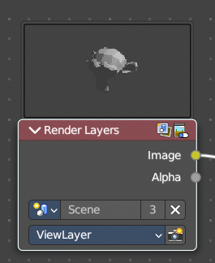
Some nodes has two icons up right. The right icon is a button that allows you to expand the node and to show a preview image.

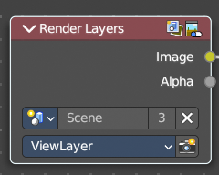

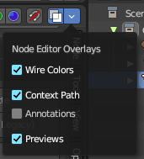
You can also toggle all node previews from the overlays drop down to the top right of the header.

Collapsing Nodes

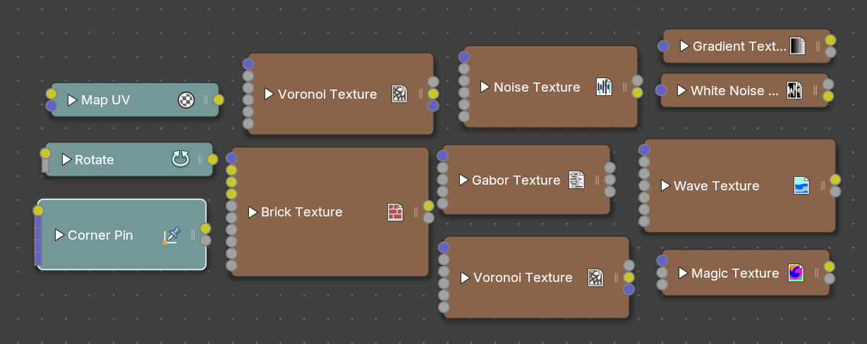
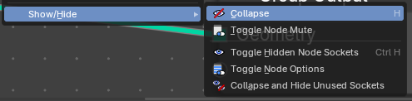
When clicking on the arrow of the header on a node, you can collapse the node to show only the name and icon.
You can either collapse using the context menu, header menu or hotkey with the Show/Hide – Collapse operator.

Rename Socket names

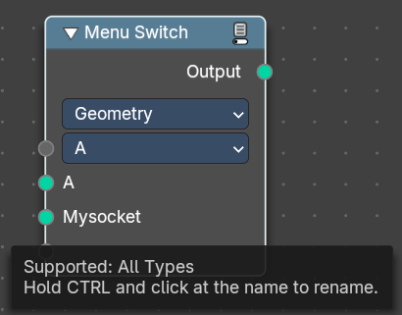
In some nodes you can rename the socket names by holding down CTRL and click at the name.

Node drag search

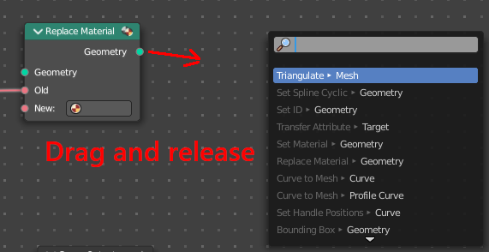
When you grab a node input or output, drag it around, and release it in the empty space, then you will get a search menu with the available nodes that fits to this input or output.

Node context menu

When you double right click into the viewport, then you will open a menu. The UV Context menu. Its content is to 100% double content to already existing menus. And it is despite the name not contextual. It does though show different content under different circumstances.

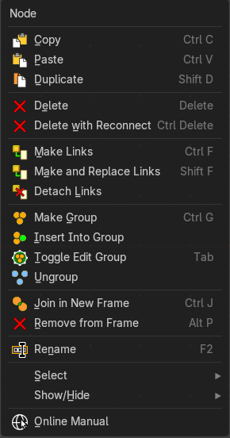
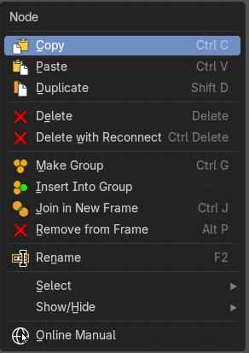
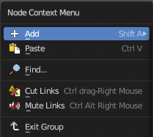
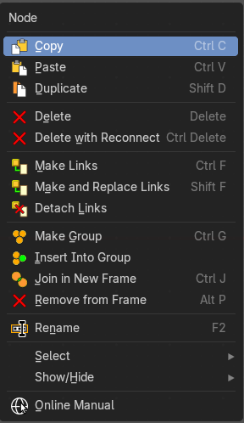

Add
The whole add menu from the header.

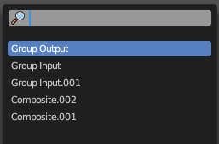
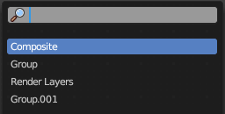
Find
Search for nodes, and hilight them. When you are in a node group then it lists the content of the node group.

Cut Links
Calls a cut tool with which you can cut links between nodes

Mute Links
Calls a cut tool with which you mute cut links between nodes. To unmute the links use the same tool again.

Exit Group
Same as Edit Group. When you are in a group then you can end editing with this operator.

Copy
Copies the selected nodes.

Paste
Pastes the copied nodes.

Duplicate
Duplicates the selected nodes.

Rename
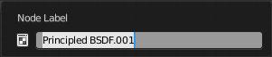
Allows you to rename the current active node. A popup opens up where you can type in another name.

Delete
Deletes the selected nodes. All Connections gets removed.

Delete with Reconnect
Deletes the selected nodes. Existing connections gets bypassed as if the node would not have existed.

Make Links
Shows when you have at least two nodes connected.
Tries to connect nodes where it makes sense. For example, the BSDF output of a Principled shader with the Surface input of the Material Output node.

Make and Replace Links
Shows when you have at least two nodes connected.
Same as Make Links. But it will replace existing links.

Detach Links
Shows when you have at least two nodes connected.
Removes all connections from the selected node, but tries to reconnect the remaining nodes.

Make Group
Groups the selected nodes together.
Select the nodes that you want to group together. Choose Make Group. You will now see a green background. This indicates that the group is created, and that you are in edit mode for the group now.




To exit the group edit mode press Tab key, or choose Toggle Edit Group menu item in the sidebar in the Relations tab in the Group panel. That way you can also enter the Group Edit mode again.




There is a third way to enter the group edit mode. Click at the right upper icon of the group node.


A group can be further collapsed by clicking at the triangle button in the upper left corner.


The group can be renamed in the sidebar in the Item tab and in the Properties tab in the Node panel.

Insert into Group
Allows you to insert a node into a node group.
Select the node, hold down Shift, then select the node group so that both are selected. Then perform the operator.

Toggle Edit Group
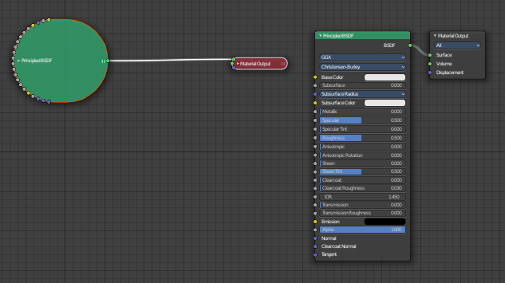
Enters a node group for editing. Or when you are in a node group, exits the node group editing.

Ungroup
Removes the selected nodes from a group.

Join new Frame
Frame node functionality. Adds the selected node to a frame.

Remove from Frame
Frame node functionality. Removes the selected node from a frame.

Rename
Allows you to rename a node.

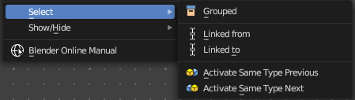
Select submenu

Grouped
Select grouped nodes.

Linked From
Select the nodes that are linked from the currently selected nodes. The nodes before in the hierarchy.

Linked To
Select the nodes that are linked to the currently selected nodes. The nodes behind in the hierarchy.

Activate same type previous
Activate same node type before the current selection, step by step.

Activate same type next
Activate same node type after the current selection, step by step.

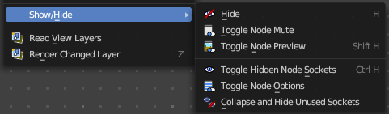
Show/Hide submenu
Here you find hide options to make the display of nodes more compact.


Demonstration happens at an image node.


Hide
Hides everything but input and output dots. To view the full node again perform the operator again. It's a toggle. Or click at the triangle left besides the node name.


Toggle Node Mute
Deactivates the node.

Toggle Node Preview
This is a compositor feature for the preview image. It does not belong here, but shares the same menu. It shows or hides the preview image.

Toggle hidden node sockets

Toggles away the unused node sockets. In this case the vector input node socket and the alpha output node socket will be hidden.


Toggle Node Options
Hides away the properties.


Collapse and Hide Unused Sockets
Like Hide. Hides everything but the node sockets. But it also hides the unused node sockets.

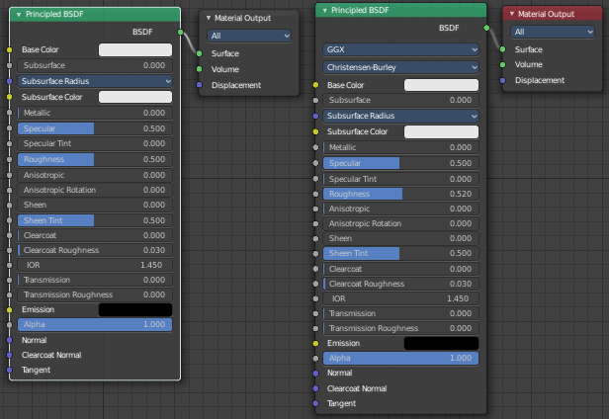
Toggle Node Options
Shows or hides the node options.

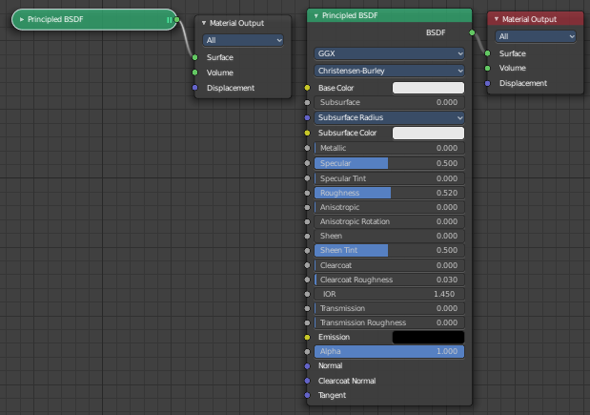
Collapse and Hide Unused Sockets
Shows or hides unused sockets.

Quick Favorites menu


When you right click at a menu or a button, then a right click menu will open. Tools have usually a Add to Quick Favorites menu entry.


The Quick Favorites Menu is empty by default. With Add to Quick favorites you can add this menu to the Quick menu.
In the 3D view we have a menu called Quick in the header, which shows this content then. In the Image Editor you can just call it with its hotkey. Q. It has no regular menu entry here.

Slider snapping
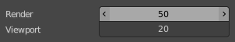
Snapping also works at sliders. Hover with the mouse over the slider, start to slide, and holding down Ctrl will snap the sliders in incremental steps.
When it's a default value between 0 and 1 then it usually snaps in 0.1 steps. When it's a default value over 1 then it usually snaps in steps of 10.

Hotkey only functionality

Important! These hotkeys works with the default Bforartists key map And they do not list the Ndof hotkeys. Ndof is a 3d connexion mouse device that is also used for tablets.
Most of the tools can be found in the graphical UI. But there are still some tools that are hotkey only. Some have a UI brother with equal functionality. For example, Pick shortest path is the hotkey sister of Select shortest path. Some are hotkey only since they cannot be integrated in the graphical UI. Like calling the File menu under the mouse. Or mouse position dependent functionality like selecting an edge loop.
The navigation hotkeys and the context menus are excluded here since they are already covered.

Back image Sample - Alt Right Mouse
Displays the color information of the Background Image under the current mouse position. Position, RGB Values, HSV, etc. . You need to have a Viewer node in the compositing chain, and the background image must show.

